MRXCAT with ERIC: extra-dimensional respiration with inflow of contrast

a MATLAB-based app designed for testing of MR sampling and reconstruction of abdominal dynamic contrast-enhanced MRI

Date: March 20, 2023

Author: Eric M. Schrauben, PhD

[e.m.schrauben@amsterdamumc.nl](mailto:e.m.schrauben@amsterdamumc.nl)

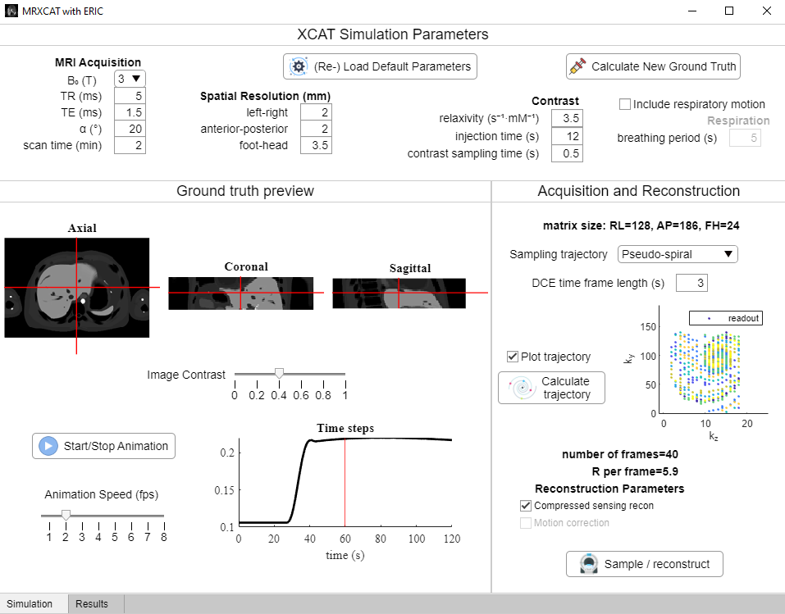

Figure 1. Example screenshot of Simulation tab.

Table of Contents

Introduction 2

Description 2

Citation 2

Contributions 2

Setup and installation: 3

Required MATLAB toolboxes: 3

Additional toolboxes: 3

Basic Processing Steps and Information: 4

Getting started 4

Simulation tab 5

XCAT Simulation Parameters 5

Ground truth preview 6

Acquisition and Reconstruction 6

Results tab 9

References 10

# Introduction

### Description

MRXCAT with ERIC is a free and open-source MATLAB-based software for digital simulation phantom (using the MRXCAT framework[1]) of DCE MRI acquisition and reconstruction strategies. The phantom is a user-friendly graphical user interface, allowing for variable respiratory motion, acquisition parameters and trajectories, motion correction strategies, and compressed sensing reconstructions. It can be used to investigate varying strategies for producing high quality DCE reconstructions in the presence of respiratory motion and contrast inflow. The phantom is intended for research use only and NOT FOR DIAGNOSTIC USE.

### Citation

The source code for this work is freely available on GitHub: <https://github.com/schrau24/XCAT-ERIC>. Any use of this phantom or software derived from it should cite this page.

### Contributions

Found a bug? Have you added new/better features? Let us know! We are keen to improve the usability and accessibility of this phantom for everyone. With GitHub’s standard git features we can easily merge your new feature branches.

# Setup and installation:

The phantom is based on MATLAB’s appdesigner functionality. It was built using MATLAB version 2019a – it is recommended to use this version or newer for running the app. Download and unzip all files.

## Required MATLAB toolboxes:

The following toolboxes from MATLAB are used by the phantom:

* Image Processing Toolbox
* Parallel Computing Toolbox

## Additional toolboxes:

The phantom uses additional toolboxes for non-Cartesian sampling and reconstruction, compressed sensing reconstruction, and 3D segmentation for motion correction:

* [gpuSparse](https://github.com/marcsous/gpuSparse) and [nufft_3d](https://github.com/marcsous/nufft_3d) from Mark Bydder. *Note these are provided with the package but may need to be recompiled within MATLAB.*
* [nufft](http://web.eecs.umich.edu/~fessler/code/index.html) from Jeff Fessler and the Michigan Image Reconstruction Toolbox. *Note future versions of the phantom will reduce the nufft redundancy.*
* [bart](https://github.com/mrirecon/bart), either on a linux system or using a [Windows-based install](https://bart-doc.readthedocs.io/en/latest/install.html). This code was tested using bart version 0.4.03
* [imtool3d](https://github.com/tanguyduval/imtool3D_td) from Tanguy Duval – an intuitive MATLAB-based segmentation tool. Supplied with the app. Used for motion correction.

# Basic Processing Steps and Information:

## Getting started

To start, open MATLAB at the folder containing MRXCATwERIC.mlapp and type:



Here is the initial screen:

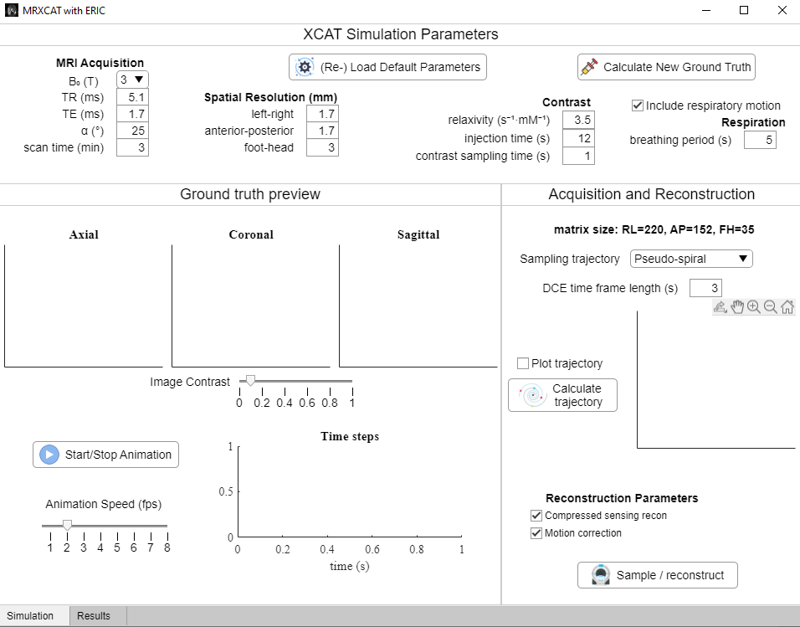

Figure 2. Initial view of the app.

The XCAT-ERIC app is sorted into two main tabs: Simulation and Results

## Simulation tab

The bulk of the app is devoted to the Simulation tab, which is split up into three main sections: XCAT Simulation Parameters, Ground truth preview, and Acquisition and Reconstruction.

### XCAT Simulation Parameters

This is the starting point for simulation, and these parameters are used to generate ground-truth images for the simulation. Pre-defined datasets can also be loaded by clicking the **(Re-) Load Default Parameters**.

To generate new contrast, select various scan settings to simulate as explained in Table 1. Once all parameters are set in this section, click **Calculate New Ground Truth**. This creates a pop-up which asks for the user to select the extent of foot-head coverage to simulate (Figure 3). *Note: more food head coverage or smaller spatial resolution in the foot-head direction increases simulation time.*

##### Details

Simulation parameters are used in the spoiled GRE signal equation per tissue to generate realistic image contrast. Breathing motion is induced through the user choice of respiratory period length – here, expiration is assumed to be ≈40% of the respiratory period. Dynamic inflow of gadolinium-based contrast in the liver, spleen, kidneys, and pancreas is simulated. Signal curves in each organ are derived from previously published DCE parameters using the extended Tofts model[2].

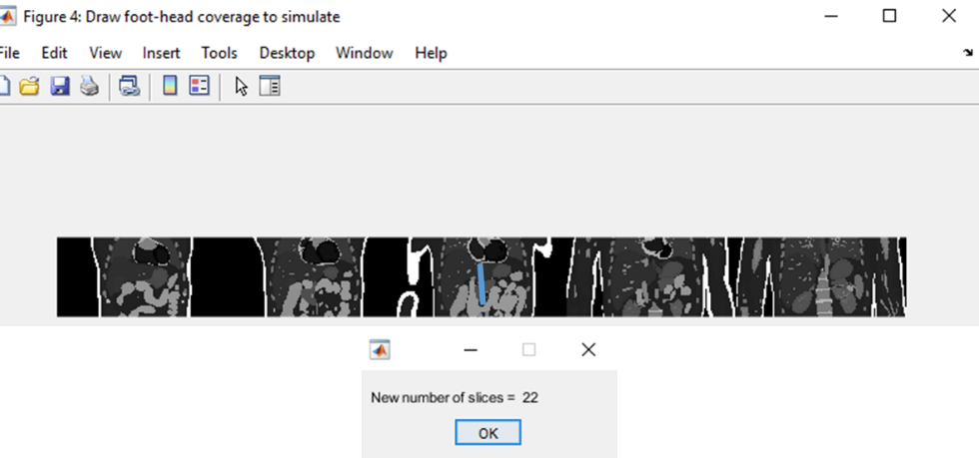

Figure 3. User selection of foot-head coverage (blue). Combined with foot-head spatial resolution, this determines the number of slices to simulate. This number is reported to the user.

Table 1. User defined parameters to generate new simulation images.

|  |  |
| --- | --- |
| XCAT Simulation Parameters | |
| Parameter | **Description** |
| B0 (T) | main magnetic field strength, 1.5T and 3T supported |
| TR (ms) | repetition time |
| TE (ms) | echo time |
| α (⁰) | excitation radiofrequency flip angle |
| scan time (min) | total simulated scan time |
| spatial resolution (mm) | spatial resolution of scan, determines matrix size for abdominal coverage |
| relaxivity (s-1 mM-1) | contrast medium relaxivity for uptake |
| injection time (s) | contrast injection time from start of the scan |
| contrast sampling time (s) | images are created (sampled) at this frequency, the total number of 3D images created is: (scan time [s])/(contrast sampling time) |
| Include respiratory motion checkbox | Option to add respiratory motion the simulation |
| breathing period (s) | respiration is assumed to be periodic at this frequency |

### Ground truth preview

Once all contrast (and optional respiratory frames) have been simulated, the ground truth images appear in the Ground truth preview section. Image contrast can be altered using the **Image Contrast** slider. These images entail three orthogonal views, cross-hairs to determine the current spatial location, and the time curve corresponding to that spatial location. Different tissues and time-points can be interrogated interactively by clicking on the appropriate axis (Figure 4). There is also an option to view changing images over time using the **Start/Stop Animation** button, which will play at the frame per second speed determined by the **Animation Speed** slider. Before continuing with other simulation steps, it is advised to stop the animation.

*Note: as these are large 4D images the true animation update speed is often limited by the computer graphics hardware.* An example animation is shown on the [GitHub](https://github.com/schrau24/XCAT-ERIC) page.

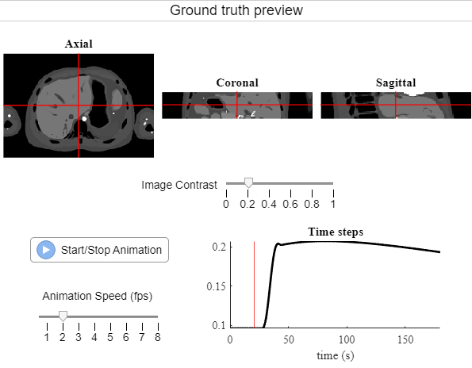

Figure 4. Ground truth preview

### Acquisition and Reconstruction

This section determines the sampling pattern and reconstruction, performing both.

#### Acquisition

First, the user selects one of 4 sampling patterns: Cartesian, Pseudo-spiral, Stack-of-stars, and Stack-of-spirals. The user also selects the reconstructed DCE time frame length. For each sampling pattern type, additional options are available (Figure 4). The **Calculate trajectory** button calculates the trajectory for the whole scan, and if the **Plot trajectory** checkbox is selected, an animated version of one DCE frame is shown. Finally, the app reports the number of reconstructed DCE frames and undersampling *R* per frame.



Figure 5. Example sampling patterns for a given matrix size and user-defined DCE frame length, (here: 3 seconds). Each sampling pattern has options to reduce sampling requirements, which ultimately contribute to the undersampling R for each DCE time frame.

#### Reconstruction

Reconstruction parameters are dependent on the sampling pattern type and whether or not respiratory motion has been added. These are determined through checkboxes underneath **Reconstruction parameters**. When the **Sample / reconstruct** button is pressed, the user is asked to supply the SNR and whether to determine respiratory signal from the sampled data or from the ground truth respiratory curve.

Feedback on the sampling and reconstruction is provided throughout simulation. If respiratory compensation is used, the sorted respiratory position (plus curve) is displayed (Figure 6). Calculated coil sensitivities, hard-coded for spherical coverage from 8 coils, are displayed (Figure 7). The MATLAB command window also displays current status for compressed sensing reconstruction.

##### Details

Data sampling using the prescribed trajectory is performed for each unique combined contrast and respiratory phase. For Cartesian trajectories, k-space from the current image is produced through simple 3D FFT and individual readouts from the current sampling time are added to the sampled set. With non-Cartesian trajectories a true 3D non-uniform FFT ([NUFFT](https://github.com/marcsous/nufft_3d)) is used for sampling. Respiratory compensation or correction can be chosen to be either a soft-gating[3] (for non-Cartesian) or autofocus approach[4] (Cartesian). DCE CS reconstructions are performed utilizing established techniques for comparison of resulting DCE images using GRASP[5] (non-Cartesian) or bart[6] (Cartesian).

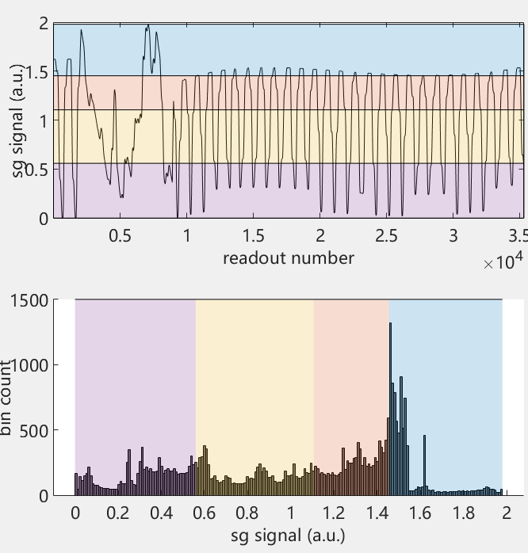

Figure 6. Example derived respiratory signal from sampled k-space, sorted into 4 respiratory bins for soft-gating

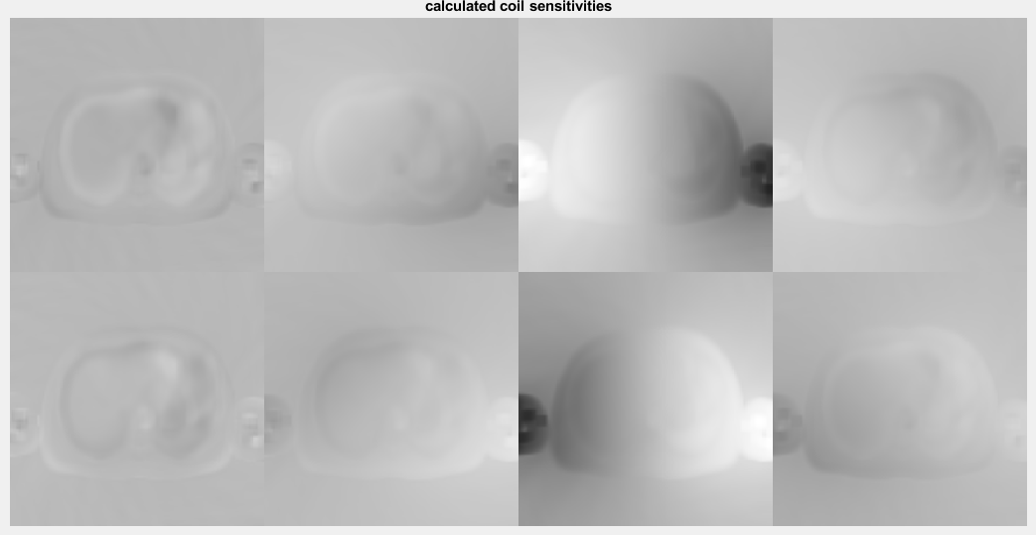

Figure 7. Example calculated coil sensitivities in the central slice for a stack-of-spirals scan.

## Results tab

The Results tab displays the ground truth images above the simulated sampled and reconstructed results (Figure 8). The user can again interactively click and display the contrast curves at specific locations, comparing the ground truth curves with the final reconstructed curves.

All results can be saved by clicking **Save results**. This will save the ground truth and reconstructed images, as well as all simulation parameters into a MATLAB struct with the prefix ‘simulated_results_’ plus the current date and time.

Before starting a new simulation, it is advised to reset the app to its default setting. This is done using the **reset app** button.

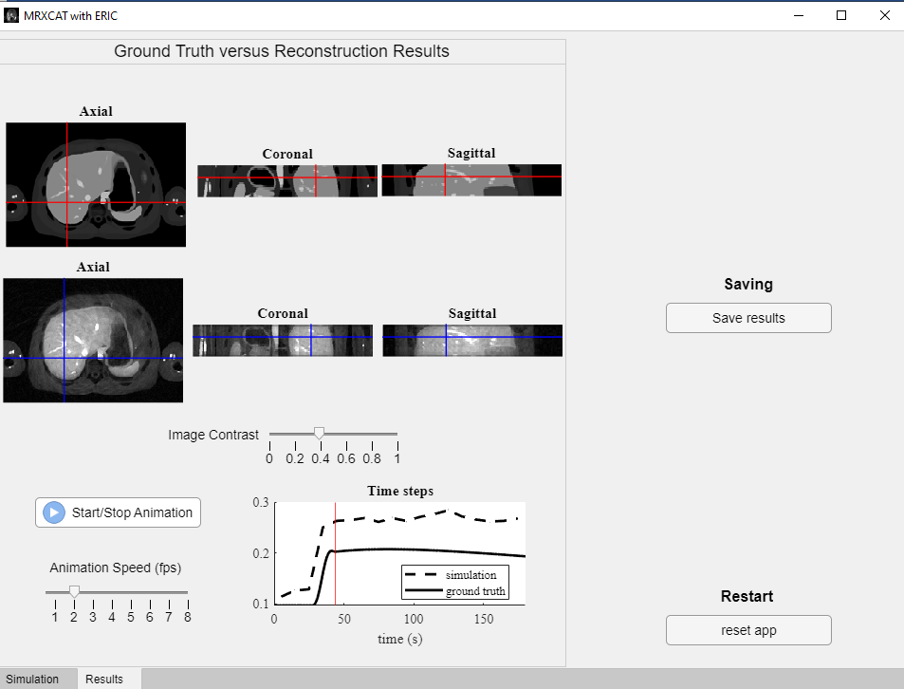

Figure 8. Example Results tab from stack-of-spiral acquisition with DCE frame length = 10 s.

## References

1. Wissmann, L., Santelli, C., Segars, W. P. & Kozerke, S. MRXCAT: Realistic numerical phantoms for cardiovascular magnetic resonance. J. Cardiovasc. Magn. Reson. 16, 1–11 (2014).
2. Klaassen, R. et al. Repeatability and correlations of dynamic contrast enhanced and T2* MRI in patients with advanced pancreatic ductal adenocarcinoma. Magn. Reson. Imaging 50, 1–9 (2018). Holland, M. D. et al. Disposable point‐of‐care portable perfusion phantom for quantitative DCE‐MRI. Med. Phys. 49, 271–281 (2022).
3. Cheng, J. Y. et al. Free-breathing pediatric MRI with nonrigid motion correction and acceleration. J. Magn. Reson. Imaging 42, 407–420 (2015).
4. Atkinson, D., Hill, D. L. G., Stoyle, P. N. R., Summers, P. E. & Keevil, S. F. An autofocus algorithm for the automatic correction of motion artifacts in MR images. Lect. Notes Comput. Sci. (including Subser. Lect. Notes Artif. Intell. Lect. Notes Bioinformatics) 1230, 341–354 (1997).
5. Feng, L. et al. Golden-angle radial sparse parallel MRI: combination of compressed sensing, parallel imaging, and golden-angle radial sampling for fast and flexible dynamic volumetric MRI. Magn. Reson. Med. 72, 707–717 (2014).
6. Uecker, M. & Tamir, J. mrirecon/bart: version 0.5.00. (2019) doi:10.5281/ZENODO.3376744.